ADLS --ADD role assignment

1.storage blob data contributor
2. Storage account contributor
3. Eventgrid eventsubscription data contributor
4.eventgrid data contributor

To the access connector

sales_df=spark.read.csv("/Volumes/cat_ltm0007ak/schema_data_integration_ak/ext_vol_anand/superstore.csv",header=True,inferSchema=True)
display(sales_df)

sales_india_df=sales_df.filter("country='India'")

sales_india_df.write.mode("overwrite").save("/Volumes/cat_ltm0007ak/schema_data_integration_ak/ext_vol_anand/india_sales")

sales_india_df.write.mode("overwrite").format("delta").save("/Volumes/cat_ltm0007ak/schema_data_integration_ak/ext_vol_anand/india_sales_delta")

Learnlytica | Databricks Advanced – Lakeflow & Data Ingestion

Module objective: Understand how an enterprise Databricks Lakehouse is architected, how Delta Lake manages reliable data, how batch and real-time ingestion pipelines operate, and how incremental processing, CDC, compaction, and governance are implemented.

1. Training schedule and learning outcomes
Session | Content | Practical outcome
Session 1 | Lakehouse architecture, control plane vs. compute plane, cluster and warehouse architecture, multi-workspace governance | Design an enterprise Lakehouse and inspect Delta internals
Session 2 | Parquet vs. Delta, Delta transaction log, batch ingestion, ingestion patterns, partitioning and compaction | Build Bronze and Silver Delta tables and inspect storage behavior
Session 3 | Incremental ingestion, CDC, MERGE, data quality, Auto Loader, ingestion tuning | Develop an incremental ingestion workflow with updates and deletes
Session 4 | Structured Streaming, late-arriving data, checkpoints, watermarks and real-time architecture | Implement and validate a streaming pipeline

Common business scenario
You are a data engineer working for Learnlytica Retail, a company processing online purchases, customer updates and payment transactions.
The company needs to process historical orders, ingest newly arriving records, update existing transactions, handle delayed events, and make consistent data available for analytics.
Throughout the day, the same datasets and business rules will be reused.

Session 1 – Enterprise Lakehouse Architecture

2. What is a Data Lakehouse?
Definition: A Data Lakehouse is a unified data architecture that combines the scalable, low-cost storage of a data lake with the reliability, data management, transactional consistency and SQL analytics features of a data warehouse.
Traditional data platforms often maintain separate systems for raw data and business analytics. A Lakehouse reduces unnecessary data movement by allowing multiple workloads to operate on governed data in cloud object storage.

Data Lake vs. Data Warehouse vs. Lakehouse
Feature | Data Lake | Data Warehouse | Lakehouse
Primary purpose | Store raw and varied data | Structured analytics | Unified analytics and engineering
Data types | Structured, semi-structured, unstructured | Primarily structured | All major data types
ACID transactions | Not inherent in raw files | Yes | Yes, using transactional table formats
Schema enforcement | Usually reader-dependent | Strong | Supported by table formats
Batch processing | Yes | Yes | Yes
Streaming processing | Possible | Platform-dependent | Supported
Data governance | Requires additional services | Built-in capabilities | Centralized using Unity Catalog
Typical storage | S3, ADLS, GCS | Managed warehouse storage | Cloud object storage with table metadata

3. Databricks Lakehouse architecture
Logical medallion architecture. Unity Catalog governance and Delta Lake transactional storage span the data layers.

Understanding the three medallion layers
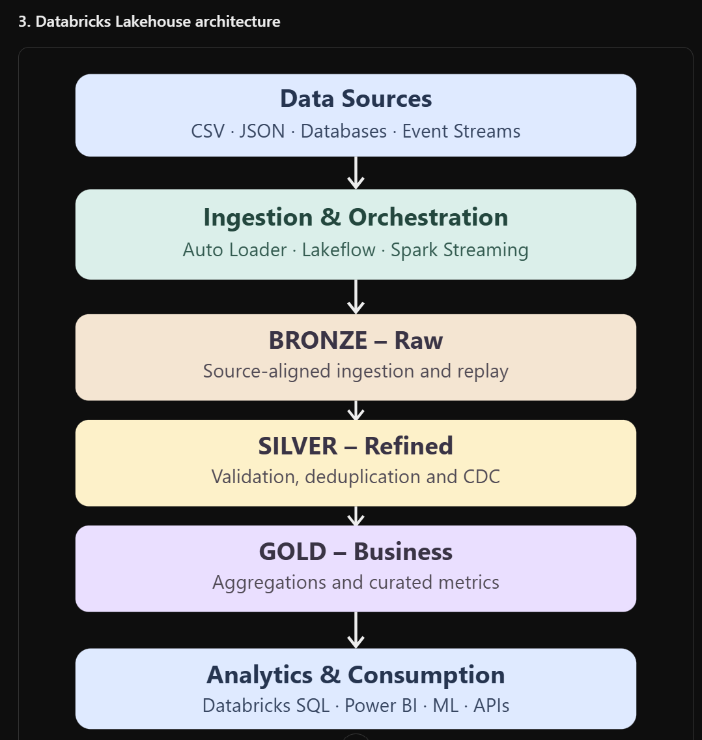
Bronze – Raw ingestion
Bronze stores data received from source systems with minimal transformation, typically retaining source identifiers and ingestion timestamps.
Example: An orders CSV containing order_id, customer_id, amount, status, and order_timestamp is ingested into bronze_orders.
Silver – Cleansed and validated data
Silver applies business rules, type conversion, deduplication, filtering, enrichment and CDC processing.
Example: Remove invalid order amounts, handle duplicate order IDs, standardize status values and retain the latest valid order state.
Gold – Analytics-ready data
Gold provides business-oriented tables for reporting and consumption.
Example: Calculate daily revenue, total orders and average order value.
Real-time use case: The finance team can use Gold tables to monitor sales without separately rebuilding the ingestion and cleaning logic in Power BI.

4. Control plane vs. compute plane

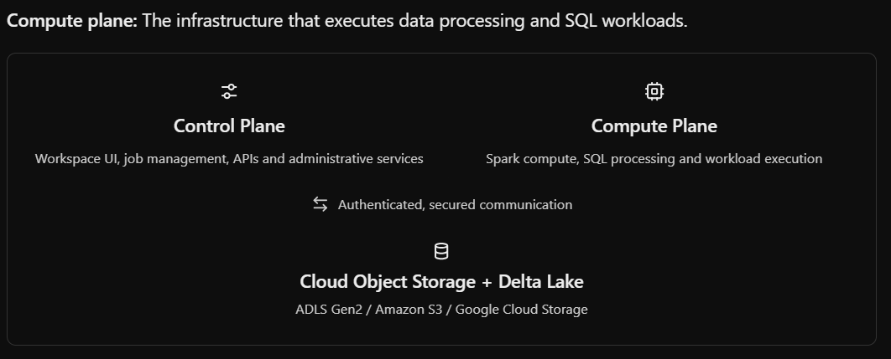
Control plane: The Databricks-managed services responsible for workspace interfaces, administration, orchestration and management functionality.
Compute plane: The infrastructure that executes data processing and SQL workloads.
Control Plane
Workspace UI, job management, APIs and administrative services
Compute Plane
Spark compute, SQL processing and workload execution
Authenticated, secured communication
Cloud Object Storage + Delta Lake
ADLS Gen2 / Amazon S3 / Google Cloud Storage
There are two main compute-plane deployment models:
- Classic compute: Compute resources run inside the customer's cloud account or subscription.
- Serverless compute: Databricks manages the compute infrastructure in its serverless compute plane.
This separation is important for security, networking, workload isolation, infrastructure cost and operational responsibility.

5. Cluster architecture
A Spark cluster contains a driver and, for distributed configurations, worker executors.
Component | Definition | Responsibility
Driver | Coordinates the Spark application | Builds execution plans and schedules tasks
Executor | Runs computations on worker resources | Processes partitions and performs shuffle operations
Worker node | Compute resource hosting executor processes | Supplies CPU, memory and execution capacity
Cluster manager | Manages compute resources | Allocates resources and coordinates compute lifecycle
Spark task | Smallest scheduled unit of computation | Processes a partition in a stage
Shuffle | Data redistribution between partitions | Supports joins, aggregations and repartitioning
A single-node compute configuration can run the driver and execution work on one node. Serverless environments abstract much of the infrastructure configuration.

SQL warehouse vs. Spark job compute
SQL Warehouse | Spark Job Compute
Optimized for SQL query workloads | Executes notebooks, PySpark, ETL and jobs
Supports BI tool connectivity | Supports custom data processing
Commonly used with Databricks SQL | Commonly used for engineering workflows
Serverless or supported classic warehouse options | Serverless jobs or classic job compute
Example: Power BI sales report | Example: Daily order cleansing pipeline

6. Multi-workspace governance
Definition: Multi-workspace governance is the centralized management of data access, metadata, and security across multiple Databricks workspaces.
Example architecture:
Databricks Account
|
+-- Unity Catalog Metastore (Region A)
| |
| +-- dev_catalog
| +-- test_catalog
| +-- prod_catalog
|
+-- Development Workspace
+-- Testing Workspace
+-- Production Workspace
Multiple eligible workspaces within the same region can share a metastore. Workspace bindings and Unity Catalog grants can restrict where catalogs are accessible and which principals can use specific objects.
Databricks on AWS
+1
This architecture helps separate development from production while maintaining centralized governance.

Session 1 – Exercise 1: Architecture identification
Scenario: Learnlytica Retail requires a platform for CSV data, near-real-time order processing, secured access and Power BI dashboards.
Tasks:
- Identify the data source, ingestion component, compute plane and storage system.
- Design Bronze, Silver and Gold layers.
- Explain where Unity Catalog operates.
- Identify which compute should execute a PySpark transformation.
- Identify which SQL warehouse serves BI queries.
- Explain how development and production workspaces should be isolated.
Expected submission: One architecture diagram and a short explanation of each component.

Session 1 – Exercise 2: Inspect the workspace and compute
Run the following in a Databricks Python notebook:
# Inspect current Spark applicationprint("Spark Version:", spark.version)# Current database and catalog contextspark.sql("""SELECT current_catalog() AS catalog_name, current_schema() AS schema_name, current_user() AS login_user""").show(truncate=False)# Examine parallel executiondf = spark.range(0, 100000)print("Partitions:", df.rdd.getNumPartitions())
The .rdd inspection can be unavailable on some serverless compute environments. If so, use the Spark UI and query profile to inspect task parallelism instead.
Additional tasks:
- Inspect the Compute page, if accessible.
- Identify whether the notebook uses classic or serverless compute.
- Open the Spark UI or query profile if supported.
- Execute df.groupBy().count().show().
- Explain what runs on the driver and what runs in distributed tasks.
Expected result: The count must equal 100000, and the trainee must explain driver/executor responsibilities.

Session 2 – Delta Lake Internals, File Formats & Batch Ingestion

7. What is Delta Lake?
Definition: Delta Lake is an open table format and transactional storage layer that adds ACID transactions, schema enforcement, time travel and reliable data modification capabilities to data stored in a data lake.
In Databricks, Delta Lake commonly stores table data in Parquet files while maintaining transaction metadata in a Delta transaction log.

Delta Lake architecture

Delta transaction log
The _delta_log directory stores the ordered sequence of transactions affecting the table. Log actions describe additions and removals of files, metadata changes, protocol requirements and other transaction details.
A conceptual table layout looks like:
orders_delta/
|
+-- _delta_log/
| +-- 00000000000000000000.json
| +-- 00000000000000000001.json
| +-- 00000000000000000002.json
| +-- checkpoint files
|
+-- part-00000-....snappy.parquet
+-- part-00001-....snappy.parquet
The filenames above are illustrative. Actual checkpoint and Parquet filenames depend on runtime and configuration.

ACID properties
Property | Definition | Retail example
Atomicity | Transaction changes are committed as a unit or not committed | An order update must not leave a partially committed transaction
Consistency | Transactions preserve enforced table constraints and metadata rules | A schema-incompatible write fails unless evolution is explicitly allowed
Isolation | Concurrent transactions operate with defined isolation and conflict handling | A report reads a consistent snapshot while a job updates orders
Durability | Committed changes survive failures | Completed order ingestion remains committed after compute failure

8. Parquet vs. Delta
Parquet is a columnar file format optimized for efficient storage and analytical scans.
Delta is a transactional table format that uses Parquet data files along with the Delta log and protocol.
Capability | Parquet files alone | Delta table
Columnar storage | Yes | Yes
Compression | Yes | Yes
Predicate pushdown | Yes | Yes
Transaction log | No | Yes
ACID table transactions | Not inherently | Yes
UPDATE / DELETE / MERGE | Requires custom file management | Built-in
Time travel | Not inherent | Supported
Schema enforcement | Reader/writer-dependent | Table-level enforcement
Streaming integration | Supported by Spark in appropriate patterns | Supported with transactional semantics
When to use Parquet: File exchange, archival datasets, interoperable analytical data and workflows that do not require Delta transactional operations.
When to use Delta: Lakehouse tables requiring reliable ingestion, corrections, incremental processing, governance and historical versions.

9. Delta table versions and time travel
Every successful data-changing Delta commit advances the table version.
Example:
Version | Operation | Logical result
0 | CREATE / initial write | Initial orders
1 | INSERT | New orders added
2 | UPDATE | Existing order changed
3 | DELETE | A record removed
4 | MERGE | CDC changes applied
Time travel lets users read a retained historical version of the table.
DESCRIBE HISTORY retail_ms2.bronze.orders;

SELECT *
FROM retail_ms2.bronze.orders VERSION AS OF 0;
The version-0 query requires the relevant historical data files and log history to remain available. Time travel is not a permanent backup mechanism; retention and VACUUM affect recoverability.

10. Data compaction and optimization
Data compaction: The process of combining multiple small data files into fewer, appropriately sized files to reduce metadata, file-opening and scan overhead.
A typical small-file problem occurs when streaming ingestion or frequent small append jobs create numerous files.
Before compaction:
1000 tiny Parquet files
|
v
OPTIMIZE
|
v
Fewer, larger Parquet files

Optimization concepts
Concept | Definition | Usage
Small-file problem | Excessive small files add scheduling and scan overhead | Frequent micro-batch ingestion
OPTIMIZE | Rewrites files to improve layout | Reduce file fragmentation
Auto compaction | Automatically combines eligible small files | Reduced manual maintenance
Data skipping | Avoids scanning files whose statistics exclude query results | Selective filters
ZORDER | Legacy multidimensional data co-location technique | Existing non-liquid-clustered tables
Liquid clustering | Flexible data organization using clustering keys | Recommended for many new Delta tables
Partitioning | Organizes data by partition column values | Select large tables with suitable partition keys
Databricks recommends liquid clustering rather than routinely introducing static partitioning and ZORDER in new Delta table designs. OPTIMIZE applies compaction and appropriate table-layout optimization according to the table configuration.

Partitioning example
( orders_df.write .format("delta") .mode("overwrite") .partitionBy("order_date") .saveAsTable("retail_ms2.bronze.orders_partitioned"))
Static partitioning should be selected based on table size, cardinality and query patterns. It is generally inappropriate to partition a small table by a nearly unique identifier such as order_id.

11. Hands-on foundation – Common dataset setup
All remaining exercises use a common Learnlytica Retail dataset.
Prerequisites: Unity Catalog enabled, permission to create objects in an authorized catalog/schema, and a Databricks notebook attached to supported compute.
The examples below assume the trainee can create schemas in the existing workspace catalog. If that catalog is not available, replace retail_ms2 with an authorized existing catalog and use the same schema/table names.

Step 1 – Create the database structure
Run in SQL:
CREATE SCHEMA IF NOT EXISTS retail_ms2.bronze;
CREATE SCHEMA IF NOT EXISTS retail_ms2.silver;
CREATE SCHEMA IF NOT EXISTS retail_ms2.gold;
These commands assume retail_ms2 already exists and the user has the required privileges. An administrator may instead create it:
CREATE CATALOG IF NOT EXISTS retail_ms2;
For the exercises that follow, we assume the catalog and schemas are ready.

Step 2 – Create source data using PySpark
PYSPARK NOTEBOOK – SETUP CELL
from pyspark.sql import functions as Ffrom pyspark.sql.types import ( StructType, StructField, IntegerType, StringType, DoubleType)orders_data = [ (1001, 101, 1200.0, "COMPLETED", "2026-10-16 09:00:00"), (1002, 102, 2500.0, "COMPLETED", "2026-10-16 09:05:00"), (1003, 103, 800.0, "PENDING", "2026-10-16 09:10:00"), (1004, 101, 1500.0, "COMPLETED", "2026-10-16 09:15:00"), (1005, 104, -200.0, "COMPLETED", "2026-10-16 09:20:00"), (1006, 105, 3000.0, "CANCELLED", "2026-10-16 09:25:00"), (1007, 102, 2100.0, "COMPLETED", "2026-10-16 09:30:00"), (1007, 102, 2100.0, "COMPLETED", "2026-10-16 09:30:00")]schema = StructType([ StructField("order_id", IntegerType(), False), StructField("customer_id", IntegerType(), False), StructField("amount", DoubleType(), True), StructField("status", StringType(), True), StructField("order_ts", StringType(), True)])orders_df = spark.createDataFrame(orders_data, schema)orders_df = ( orders_df .withColumn("order_timestamp", F.to_timestamp("order_ts")) .withColumn("order_date", F.to_date("order_timestamp")) .drop("order_ts"))orders_df.show(truncate=False)

Dataset schema
Column | Data type | Description
order_id | INTEGER | Order business identifier
customer_id | INTEGER | Customer identifier
amount | DOUBLE | Order transaction value
status | STRING | COMPLETED, PENDING or CANCELLED
order_timestamp | TIMESTAMP | Business event timestamp
order_date | DATE | Derived calendar date

Source data preview
order_id | customer_id | amount | status
1001 | 101 | 1200 | COMPLETED
1002 | 102 | 2500 | COMPLETED
1003 | 103 | 800 | PENDING
1004 | 101 | 1500 | COMPLETED
1005 | 104 | -200 | COMPLETED
1006 | 105 | 3000 | CANCELLED
1007 | 102 | 2100 | COMPLETED
1007 | 102 | 2100 | COMPLETED
The dataset deliberately contains one invalid amount and one duplicate record, allowing trainees to practice realistic data engineering quality rules.

12. Session 2 – Exercise 1: Bronze and Silver ingestion
Business problem: Ingest raw order transactions without losing source information, then cleanse the records into a Silver table.

Task A – Create the Bronze table
( orders_df.write .format("delta") .mode("overwrite") .saveAsTable("retail_ms2.bronze.orders"))

Task B – Explore Bronze data
SELECT *
FROM retail_ms2.bronze.orders
ORDER BY order_id;

DESCRIBE DETAIL retail_ms2.bronze.orders;

DESCRIBE HISTORY retail_ms2.bronze.orders;
Trainees should identify the table format, table location, number of files and latest table version.

Task C – Cleanse Silver data
Business rules:
- Reject orders where amount <= 0.
- Reject rows with NULL order_id.
- Remove exact duplicate records.
- Add an ingestion timestamp.
- Preserve valid PENDING and CANCELLED orders because payment status and revenue eligibility are separate business concerns.
silver_df = ( spark.table("retail_ms2.bronze.orders") .filter(F.col("amount") > 0) .filter(F.col("order_id").isNotNull()) .dropDuplicates([ "order_id", "customer_id", "amount", "status", "order_timestamp" ]) .withColumn("ingestion_timestamp", F.current_timestamp()))( silver_df.write .format("delta") .mode("overwrite") .saveAsTable("retail_ms2.silver.orders"))

Task D – Validate results
SELECT COUNT(*) AS bronze_count
FROM retail_ms2.bronze.orders;

SELECT COUNT(*) AS silver_count
FROM retail_ms2.silver.orders;

SELECT order_id, COUNT(*) AS record_count
FROM retail_ms2.silver.orders
GROUP BY order_id
HAVING COUNT(*) > 1;
Expected validation
Bronze records

8
Silver records

6
Duplicate IDs

0

Session 2 – Exercise 2: Delta internals, OPTIMIZE and layout
Scenario: The engineering team wants to inspect transactional behavior and understand file layout maintenance.

Task A – Capture history and file metrics
DESCRIBE DETAIL retail_ms2.silver.orders;

DESCRIBE HISTORY retail_ms2.silver.orders;

Task B – Execute an update
UPDATE retail_ms2.silver.orders
SET status = 'COMPLETED'
WHERE order_id = 1003;

Task C – Inspect the version change
DESCRIBE HISTORY retail_ms2.silver.orders;

SELECT order_id, status
FROM retail_ms2.silver.orders
WHERE order_id = 1003;
Expected result: Order 1003 now has status COMPLETED.

Task D – Execute compaction
OPTIMIZE retail_ms2.silver.orders;

Task E – Inspect table details again
DESCRIBE DETAIL retail_ms2.silver.orders;
Record the numFiles and sizeInBytes values before and after.
Important: This dataset is very small. OPTIMIZE may not reduce file counts or provide measurable performance improvements. The exercise teaches the command and metadata inspection, not a guaranteed speedup.

Task F – Demonstrate Delta history
DESCRIBE HISTORY retail_ms2.silver.orders;
Compare the table state before and after the update using the actual recorded version numbers.

Optional storage exercise
Where authorized Volume access is available, inspect a path-backed Delta table's _delta_log directory. For Unity Catalog managed tables, avoid assuming that trainees can directly browse internal storage paths.

Evidence required
Two screenshots:
- Bronze/Silver validation showing record counts.
- DESCRIBE HISTORY and DESCRIBE DETAIL demonstrating Delta operations and file metrics.

Session 3 – Incremental Ingestion, Auto Loader and Change Data Capture
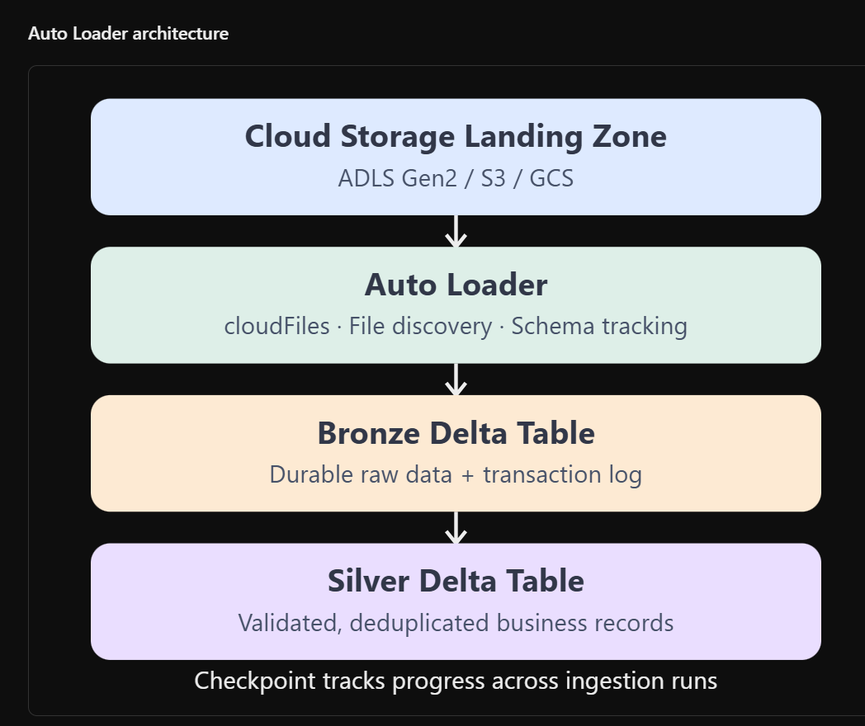

13. What is data ingestion?
Definition: Data ingestion is the process of collecting data from source systems and loading it into a target storage or processing platform.
In a Databricks Lakehouse, common sources include relational databases, SaaS applications, cloud object storage, event-streaming platforms and application-generated files.

Common ingestion patterns
Pattern | Definition | Real-world use case
Full load | Loads the entire dataset | Initial customer master migration
Incremental load | Processes only data added or changed since the prior load | Daily new orders
CDC | Captures insert, update and delete events | Customer address and account changes
Batch | Processes bounded input sets | Nightly financial files
Streaming | Continuously processes newly available events | Payment event monitoring
Micro-batch | Processes streams in small batches | Near-real-time order ingestion
File-based incremental | Detects and ingests newly arrived files | CSV/JSON landing zone
Change data feed | Reads changes committed to Delta tables | Synchronizing downstream tables

Batch vs. streaming
Batch processing | Streaming processing
Bounded dataset | Potentially unbounded input
Triggered periodically or on demand | Processes newly available events over time
Often higher end-to-end latency | Typically lower latency
Suitable for historical backfills | Suitable for near-real-time events
Simpler state management | Requires attention to state and checkpoints
Example: Daily sales reconciliation | Example: Payment fraud monitoring
Streaming does not automatically guarantee zero latency, and batch processing is not inherently less efficient. The selection depends on business service-level agreements, cost, input characteristics and operational complexity.

14. What is Auto Loader?
Definition: Auto Loader is a Databricks file-ingestion capability that incrementally processes files arriving in cloud object storage.
It uses the Structured Streaming source cloudFiles to discover and process new files without manually listing and reprocessing the entire source directory on every run. It supports cloud storage such as ADLS Gen2, S3 and GCS.
Databricks on AWS

Auto Loader architecture

Essential Auto Loader options
Property | Purpose
cloudFiles | Invokes the Auto Loader source
cloudFiles.format | Source file format such as CSV, JSON or Parquet
cloudFiles.schemaLocation | Persists inferred schema metadata
cloudFiles.inferColumnTypes | Enables type inference for supported source formats
cloudFiles.schemaEvolutionMode | Determines schema-change handling
checkpointLocation | Persists stream progress and recovery information
maxFilesPerTrigger | Controls the maximum number of new files considered per trigger, subject to source behavior
availableNow | Processes available backlog and then stops
For managed file ingestion, availableNow is useful for scheduled incremental processing. A continuously running operational stream requires appropriate streaming triggers and monitoring.

15. Auto Loader implementation
This lab assumes trainees have an existing external location and a Unity Catalog Volume mapped to an authorized storage path. It does not create a new storage account, container, storage credential or external location.
For example:
/Volumes/retail_ms2/bronze/landing/
|
+-- orders_batch_01.csv
+-- orders_batch_02.csv
The Volume must exist and trainees must have appropriate read/write privileges.

Example source schema
order_id,customer_id,amount,status,order_timestamp
2001,101,1500,COMPLETED,2026-10-16 10:00:00
2002,102,2400,PENDING,2026-10-16 10:05:00

PySpark Auto Loader code
from pyspark.sql.types import ( StructType, StructField, IntegerType, DoubleType, StringType, TimestampType)landing_path = "/Volumes/retail_ms2/bronze/landing"checkpoint_path = "/Volumes/retail_ms2/bronze/checkpoints/orders"schema_path = "/Volumes/retail_ms2/bronze/schemas/orders"source_schema = StructType([ StructField("order_id", IntegerType()), StructField("customer_id", IntegerType()), StructField("amount", DoubleType()), StructField("status", StringType()), StructField("order_timestamp", TimestampType())])stream_df = ( spark.readStream .format("cloudFiles") .option("cloudFiles.format", "csv") .option("header", "true") .option("cloudFiles.schemaLocation", schema_path) .schema(source_schema) .load(landing_path))query = ( stream_df.writeStream .format("delta") .option("checkpointLocation", checkpoint_path) .trigger(availableNow=True) .toTable("retail_ms2.bronze.autoload_orders"))query.awaitTermination()
Checkpoint best practice: Keep checkpoint directories durable, separate for each distinct streaming query and outside the source file landing path. Rerun the same ingestion query using its existing checkpoint, rather than deleting the checkpoint to force reprocessing.
The Auto Loader demonstration assumes the workspace/runtime supports the shown API and has Volume access.

16. What is incremental data ingestion?
Definition: Incremental ingestion processes records or files that are new or changed since a previously established processing point.
Rather than reloading millions of historical rows daily, the pipeline processes only the relevant additions and modifications.

Incremental loading methods
Method | How it works | Limitation
High-water mark | Read records above a stored timestamp or ID | May miss backdated changes or deletes
File discovery | Track newly arriving source files | Replaced/modified existing files need careful handling
CDC | Consume source-level change events | Requires reliable change capture and ordering
Delta Change Data Feed | Read changes from a Delta table | Requires CDF to be enabled and changes retained
MERGE | Reconcile staged changes into a destination | Needs unambiguous match keys and duplicate handling
For reliable incremental processing, the pipeline should have a clearly defined business key, source ordering, retry policy and idempotency strategy.

17. What is Change Data Capture?
Definition: Change Data Capture (CDC) is a technique for identifying and processing modifications made to source data, commonly represented by INSERT, UPDATE and DELETE operations.

Typical CDC records
order_id | operation | amount | status
1002 | UPDATE | 2600 | COMPLETED
1008 | INSERT | 1800 | PENDING
1006 | DELETE | — | —
A CDC pipeline should translate these changes into the correct destination-table state.

MERGE concept
MERGE INTO conditionally updates, deletes or inserts records based on a matching key.
MERGE INTO target_table AS t
USING source_changes AS s
ON t.order_id = s.order_id

WHEN MATCHED AND s.operation = 'DELETE'
THEN DELETE

WHEN MATCHED AND s.operation = 'UPDATE'
THEN UPDATE SET
t.amount = s.amount,
t.status = s.status

WHEN NOT MATCHED AND s.operation = 'INSERT'
THEN INSERT (
order_id, amount, status
)
VALUES (
s.order_id, s.amount, s.status
);
A production implementation should also define the behavior of updates for missing target keys, late changes, source deletes and duplicate changes.

18. Session 3 – Exercise 1: CDC using Delta MERGE
Scenario: Learnlytica Retail receives a change batch after its initial orders have already been ingested.
The change batch contains:
- Order 1002: Payment completed; amount corrected to ₹2,600.
- Order 1008: Newly created order worth ₹1,800.
- Order 1006: Cancelled order removed from the operational current-state table.

Task A – Create CDC data
Execute after the Session 2 exercises.
cdc_data = [ (1002, 102, 2600.0, "COMPLETED", "UPDATE"), (1008, 106, 1800.0, "PENDING", "INSERT"), (1006, 105, None, None, "DELETE")]cdc_schema = """order_id INT,customer_id INT,amount DOUBLE,status STRING,operation STRING"""cdc_df = spark.createDataFrame(cdc_data, cdc_schema)( cdc_df.write .format("delta") .mode("overwrite") .saveAsTable("retail_ms2.bronze.order_cdc"))

Task B – Implement CDC MERGE
MERGE INTO retail_ms2.silver.orders AS tgt
USING retail_ms2.bronze.order_cdc AS src
ON tgt.order_id = src.order_id

WHEN MATCHED AND src.operation = 'DELETE'
THEN DELETE

WHEN MATCHED AND src.operation = 'UPDATE'
THEN UPDATE SET
tgt.amount = src.amount,
tgt.status = src.status

WHEN NOT MATCHED AND src.operation = 'INSERT'
THEN INSERT (
order_id,
customer_id,
amount,
status,
order_timestamp,
order_date,
ingestion_timestamp
)
VALUES (
src.order_id,
src.customer_id,
src.amount,
src.status,
current_timestamp(),
current_date(),
current_timestamp()
);
For this introductory lab, newly inserted orders use the processing timestamp because the example CDC feed does not include a source event timestamp. In production, preserve the authoritative source event timestamp.

Task C – Validate the changes
SELECT
order_id,
customer_id,
amount,
status
FROM retail_ms2.silver.orders
ORDER BY order_id;
Expected Silver state, assuming the Session 2 update of order 1003 has already been executed:
order_id | customer_id | amount | status
1001 | 101 | 1200 | COMPLETED
1002 | 102 | 2600 | COMPLETED
1003 | 103 | 800 | COMPLETED
1004 | 101 | 1500 | COMPLETED
1007 | 102 | 2100 | COMPLETED
1008 | 106 | 1800 | PENDING

Task D – Final reconciliation checks
SELECT COUNT(*) AS total_records
FROM retail_ms2.silver.orders;

SELECT COUNT(*) AS deleted_record_count
FROM retail_ms2.silver.orders
WHERE order_id = 1006;

SELECT COUNT(*) AS updated_record_count
FROM retail_ms2.silver.orders
WHERE order_id = 1002
AND amount = 2600
AND status = 'COMPLETED';

SELECT COUNT(*) AS inserted_record_count
FROM retail_ms2.silver.orders
WHERE order_id = 1008;
Expected CDC validation
Check | Expected
Final record count | 6
Deleted order 1006 remaining | 0
Correctly updated order 1002 | 1
Newly inserted order 1008 | 1

Production discussion – Idempotency
Idempotency means rerunning an operation with the same input does not produce unintended additional effects.
For example, rerunning this MERGE does not insert order 1008 a second time because the business key already exists.
However, the implementation is a simplified current-state reconciliation example. A production CDC pipeline must correctly order multiple source changes, reject stale updates, handle late deletes, and maintain stable event identifiers or sequence numbers.
Monday's Lakeflow CDC module will cover those advanced requirements.

19. Session 3 – Exercise 2: Delta Change Data Feed
Definition: Delta Change Data Feed (CDF) provides a record of row-level changes made to a Delta table, allowing downstream systems to process modifications incrementally.
CDF must be enabled before the relevant changes occur; enabling it does not reconstruct earlier row-level changes.

Task A – Create a dedicated CDF-enabled table
CREATE OR REPLACE TABLE retail_ms2.silver.orders_cdf_demo
USING DELTA
TBLPROPERTIES (
delta.enableChangeDataFeed = true
)
AS
SELECT *
FROM retail_ms2.silver.orders;

Task B – Update a record
UPDATE retail_ms2.silver.orders_cdf_demo
SET amount = 2900
WHERE order_id = 1002;

Task C – Delete a record
DELETE FROM retail_ms2.silver.orders_cdf_demo
WHERE order_id = 1008;

Task D – Read recorded changes
DESCRIBE HISTORY retail_ms2.silver.orders_cdf_demo;
Use the actual change-table versions from history. For example, if the creation is version 0 and the subsequent changes are versions 1 and 2:
SELECT
order_id,
amount,
_change_type,
_commit_version,
_commit_timestamp
FROM table_changes(
'retail_ms2.silver.orders_cdf_demo',
1
)
ORDER BY _commit_version, order_id, _change_type;

Expected CDF output
order_id | amount | _change_type
1002 | 2600 | update_preimage
1002 | 2900 | update_postimage
1008 | 1800 | delete
This result assumes a fresh CDF demo table and only the specified update and delete after creation.
Discussion: CDF is valuable for incremental downstream processing, but it is not a substitute for a permanent audit archive. Retention settings govern how long change history remains accessible.

20. Ingestion performance tuning
Bottleneck | Symptom | Suggested action
Too many small input files | Large metadata and file-open overhead | Batch small files and tune ingestion
Repeated full loads | Unnecessary source reads | Use incremental discovery or CDC
Expensive schema inference | Increased file-processing overhead | Define stable schemas
High shuffle volume | Slow joins and aggregations | Inspect plans, reduce unnecessary shuffles
Skewed partitions | A few long-running tasks | Use adaptive execution and skew-aware strategies
Excessive partitioning | Many sparse directories/files | Use appropriate layout or liquid clustering
Repeated failed stream processing | Frequent retries | Inspect checkpoint, source and sink errors
Excessive streaming trigger frequency | Higher operational cost | Tune triggers against latency requirements
Key engineering lesson: Always measure input rate, processing duration, task execution, file sizes and scan behavior before selecting optimization techniques.

Session 4 – Real-Time Pipelines, Streaming & Late-Arriving Data

21. What is real-time data processing?
Definition: Real-time data processing is the continuous or near-continuous processing of incoming events to produce results with sufficiently low latency for business requirements.
Examples include fraud detection, logistics tracking, payment monitoring, website activity tracking and order status updates.
Databricks supports streaming workloads using Apache Spark Structured Streaming and other platform-managed ingestion and pipeline capabilities.

22. Structured Streaming architecture
Structured Streaming is a Spark API for processing streaming datasets using familiar DataFrame and SQL-style operations.
A stream can be viewed as continuously growing input data, while Spark tracks progress and executes incremental computations.

Streaming terminology
Concept | Definition | Example
Event time | Timestamp when the business event happened | Order placed at 10:00
Processing time | Timestamp when the processing engine handles the event | Event processed at 10:08
Micro-batch | A bounded set of available events processed together | Orders accumulated for the next trigger
Trigger | Controls when streaming processing is initiated | Every 10 seconds
Checkpoint | Durable progress and state information for recovery | Restart after a compute failure
Watermark | Event-time progress threshold used to bound state and late-data handling | 10-minute lateness allowance
Stateful processing | Computation retaining information between batches | Streaming deduplication
Window aggregation | Aggregation over defined time intervals | Orders per 5-minute window
Output mode | Defines how updated results are emitted | Append, Update, Complete

23. Handling late-arriving data
Definition: Late-arriving data is data that reaches the processing system after newer business events have already been observed.
Example:
order_id | Event time | Processing arrival | Delay
3001 | 10:00 | 10:01 | 1 minute
3002 | 10:03 | 10:04 | 1 minute
3003 | 09:55 | 10:09 | 14 minutes
3004 | 10:06 | 10:07 | 1 minute
In this example, order 3003 arrived considerably later than the time when it was created.

Watermarking
A watermark establishes an event-time progress boundary used by stateful operations.
Conceptually:

$Watermark≈MaxEventTimeObserved-AllowedDelay$
Spark advances watermarks based on streaming progress; exact behavior depends on micro-batch boundaries, sources and stateful operators.
With a 10-minute watermark delay, event timestamps sufficiently behind observed event-time progress may be excluded from stateful results. Longer delays accommodate more late events but require retaining more state.
Databricks on Google Cloud

Code example
from pyspark.sql import functions as Fdeduplicated_stream = ( input_stream .withWatermark("event_timestamp", "10 minutes") .dropDuplicatesWithinWatermark(["event_id"]))
This pattern uses event IDs to remove duplicate events within the configured watermark semantics. It requires a supported Databricks Runtime and an actual streaming DataFrame.

24. Session 4 – Exercise 1: Streaming ingestion using Delta
Business scenario: The retailer receives new orders as files arrive in an object-storage landing area.
Objective: Ingest the events incrementally into a Delta table, maintain a checkpoint and verify that a subsequent ingestion run processes newly added files.

Prerequisites
Use these existing authorized Volume paths:
/Volumes/retail_ms2/bronze/stream_input/
/Volumes/retail_ms2/bronze/stream_checkpoints/
If trainees have their own external locations, the same folder structure can be created under their existing storage allocation and mapped through an accessible Unity Catalog Volume.

Task A – Define the source schema and streaming DataFrame
from pyspark.sql.types import ( StructType, StructField, IntegerType, DoubleType, StringType, TimestampType)event_schema = StructType([ StructField("order_id", IntegerType()), StructField("customer_id", IntegerType()), StructField("amount", DoubleType()), StructField("event_timestamp", TimestampType()), StructField("status", StringType())])source_path = "/Volumes/retail_ms2/bronze/stream_input"checkpoint = ( "/Volumes/retail_ms2/bronze/" "stream_checkpoints/orders_stream")stream_orders = ( spark.readStream .format("cloudFiles") .option("cloudFiles.format", "json") .schema(event_schema) .load(source_path))

Task B – Write to a Delta table
query = ( stream_orders.writeStream .format("delta") .option("checkpointLocation", checkpoint) .trigger(availableNow=True) .toTable("retail_ms2.bronze.orders_stream"))query.awaitTermination()

Task C – Prepare input batch 1
Upload a JSON Lines file named events_batch_01.json containing:
{"order_id":3001,"customer_id":101,"amount":1200,"event_timestamp":"2026-10-16T10:00:00","status":"COMPLETED"}
{"order_id":3002,"customer_id":102,"amount":1500,"event_timestamp":"2026-10-16T10:03:00","status":"COMPLETED"}
{"order_id":3003,"customer_id":103,"amount":900,"event_timestamp":"2026-10-16T10:05:00","status":"PENDING"}
Create this file in the landing directory before executing Task B.

Task D – Validate first ingestion
SELECT COUNT(*) AS total_orders
FROM retail_ms2.bronze.orders_stream;
Expected result: 3

Task E – Add input batch 2
After the first query completes, upload events_batch_02.json:
{"order_id":3004,"customer_id":104,"amount":2200,"event_timestamp":"2026-10-16T10:08:00","status":"COMPLETED"}
{"order_id":3005,"customer_id":105,"amount":1800,"event_timestamp":"2026-10-16T10:09:00","status":"PENDING"}
Rerun Task B using the same checkpoint.

Task F – Validate incremental processing
SELECT COUNT(*) AS total_orders
FROM retail_ms2.bronze.orders_stream;

SELECT
MIN(order_id) AS min_order_id,
MAX(order_id) AS max_order_id,
SUM(amount) AS total_amount
FROM retail_ms2.bronze.orders_stream;
Expected results
Records

5
Total amount

7,600
Maximum order ID

3005
Key learning: A persisted checkpoint allows the pipeline to resume file discovery and processing without intentionally rereading previously completed files.
For this introductory exercise, use a new empty landing folder and checkpoint for the first run. Do not delete an active checkpoint in a production pipeline.

25. Session 4 – Exercise 2: Late-arriving event analysis
Scenario: Business events are being processed out of event-time order. The engineering team must identify how many events arrived late and determine the appropriate watermark strategy.

Task A – Create a late-event dataset
from pyspark.sql import functions as Fevents = [ (4001, "2026-10-16 10:00:00", "2026-10-16 10:01:00"), (4002, "2026-10-16 10:05:00", "2026-10-16 10:06:00"), (4003, "2026-10-16 09:50:00", "2026-10-16 10:10:00"), (4004, "2026-10-16 10:08:00", "2026-10-16 10:09:00"), (4005, "2026-10-16 10:02:00", "2026-10-16 10:20:00")]events_df = spark.createDataFrame( events, ["event_id", "event_time", "arrival_time"])events_df = ( events_df .withColumn("event_time", F.to_timestamp("event_time")) .withColumn("arrival_time", F.to_timestamp("arrival_time")))

Task B – Calculate arrival delay
delay_df = ( events_df .withColumn( "delay_minutes", ( F.unix_timestamp("arrival_time") - F.unix_timestamp("event_time") ) / 60 ) .withColumn( "arrival_category", F.when( F.col("delay_minutes") > 10, "LATE" ).otherwise("ON_TIME") ))delay_df.show(truncate=False)

Task C – Validate late-event classification
delay_df.groupBy("arrival_category").count().show()
Expected output:
Classification | Count
ON_TIME | 3
LATE | 2
The two late records are events 4003 and 4005.

Task D – Create a Gold summary
summary_df = ( delay_df .groupBy("arrival_category") .agg( F.count("*").alias("event_count"), F.round( F.avg("delay_minutes"), 2 ).alias("average_delay_minutes"), F.max("delay_minutes").alias("maximum_delay_minutes") ))( summary_df.write .format("delta") .mode("overwrite") .saveAsTable("retail_ms2.gold.event_delay_summary"))

Expected Gold table
arrival_category | event_count | average_delay_minutes | maximum_delay_minutes
LATE | 2 | 19.0 | 20.0
ON_TIME | 3 | 1.0 | 1.0

Task E – Discuss watermark behavior
Consider a Structured Streaming implementation with:
watermarked_events = ( input_stream .withWatermark("event_time", "10 minutes"))
Trainees must explain:
- Why arrival time differs from event time.
- Why watermarks are useful for stateful processing.
- Whether a 10-minute allowed delay is sufficient for the observed business data.
- Why a 30-minute threshold might increase state retention but reduce the risk of missing delayed events.
- Why it is incorrect to assume a late record is always dropped from every operation simply because .withWatermark() was applied.
Technical distinction: The event-delay exercise is a deterministic batch simulation. It teaches lateness measurement and watermark selection, but it does not itself execute a stateful streaming watermark. Actual state eviction and dropped-record behavior must be validated using a streaming stateful operation.

26. End-to-end exercise – Retail pipeline validation
At the end of the session, trainees should verify the complete ingestion and transformation workflow.

Bronze validation
SELECT
COUNT(*) AS raw_records,
COUNT(DISTINCT order_id) AS unique_orders
FROM retail_ms2.bronze.orders;
Expected:
raw_records | unique_orders
8 | 7

Silver CDC validation
SELECT
COUNT(*) AS total_orders,
SUM(
CASE WHEN status = 'COMPLETED'
THEN amount ELSE 0 END
) AS completed_revenue,
SUM(
CASE WHEN status = 'PENDING'
THEN 1 ELSE 0 END
) AS pending_orders
FROM retail_ms2.silver.orders;
Expected after all prescribed Session 2 and Session 3 changes:
total_orders | completed_revenue | pending_orders
6 | 8200 | 1

Gold aggregation
CREATE OR REPLACE TABLE retail_ms2.gold.daily_sales AS
SELECT
order_date,
COUNT(*) AS total_orders,
SUM(
CASE WHEN status = 'COMPLETED'
THEN amount ELSE 0 END
) AS completed_revenue
FROM retail_ms2.silver.orders
GROUP BY order_date;
The result groups by the stored order date. Because inserted CDC records use the actual processing date in this simplified example, the day-wise breakdown can vary if the exercise is rerun on another date. The total reconciled revenue remains ₹8,200 under the specified scenario.

27. Session-wise assignment checklist
Use this checklist to verify that all required competencies have been completed.
Practical completion
0 of 12 completed
Session 1 – Architecture
Identify Lakehouse components and medallion layers
Explain control and compute planes
Inspect Spark compute and workspace context
Session 2 – Delta Internals
Create Bronze and Silver Delta tables
Validate invalid and duplicate records
Perform UPDATE, OPTIMIZE and inspect Delta history
Session 3 – Ingestion & CDC
Explain and configure Auto Loader ingestion
Apply MERGE with INSERT, UPDATE and DELETE
Inspect Delta Change Data Feed
Session 4 – Streaming
Process incremental JSON event batches
Reuse a persistent streaming checkpoint
Calculate late-event delays and generate Gold metrics
Reset checklist

28. Daily assessment – Sample conceptual questions
Knowledge check
5 questions · Single answer
1. What is the primary purpose of the Delta transaction log?
Store only query results
Track transactional table changes
Replace Parquet data files
Allocate Spark executors
2. Which approach is best for processing newly arriving files without repeatedly scanning the entire historical dataset?
Full table overwrite
Auto Loader with a checkpoint
Repeated manual CSV loads
SELECT DISTINCT on all historical files
3. Which Spark capability is designed to bound state for late-arriving event-time data?
Repartition
Watermark
Cache
Broadcast
4. Which statement is correct about Parquet and Delta?
Parquet files alone provide Delta time travel
Delta does not use Parquet
Delta combines transactional metadata with columnar data files
Parquet is always faster than Delta
5. What is the recommended modern alternative to routinely combining static partitions and ZORDER for new Delta tables?
Liquid clustering
Global cache
Full outer joins
Manual directory sorting

